System Development Deliverable Assignment 2
Project Sponsor: Nigar Safarova
Project Name: Smart Grocery & Meal Planner
Date: September 8, 2025

SDLC Methodology Choice
Preferred approach outside class: Agile Methodologies
I would choose Agile/Scrum because it lets me build in small chunks, ship working features frequently, and learn from real feedback. Short sprints encourage frequent delivery of working features, which reduces risk and makes course corrections easy. Timeboxing creates focus, the backlog keeps priorities visible, and the cadence builds steady momentum.
Approach for this class: Waterfall Approach
Waterfall fits this class project because I am working solo, and my MVP scope is clear. The sequential phases of Planning, Analysis, Design, Implementation, Testing, and Deployment give me firm checkpoints and deliverables that match the semester schedule.
Why it works:
- One owner benefits from a step by step plan
- Course milestones align with each phase
- Core requirements are stable enough to plan up front

“Project Binder” (folder structure)
I maintain a structured, Waterfall-aligned project binder on my laptop and keep it synced to Google Drive for backup and easy sharing. The binder mirrors the SDLC phases so each deliverable has a clear home and can be reviewed quickly.
Location and Sync
- Primary location: Local folder on my laptop
- Cloud sync: Google Drive (mirrors the same structure)
- Benefit: Offline work with automatic backup and a single share link for submissions
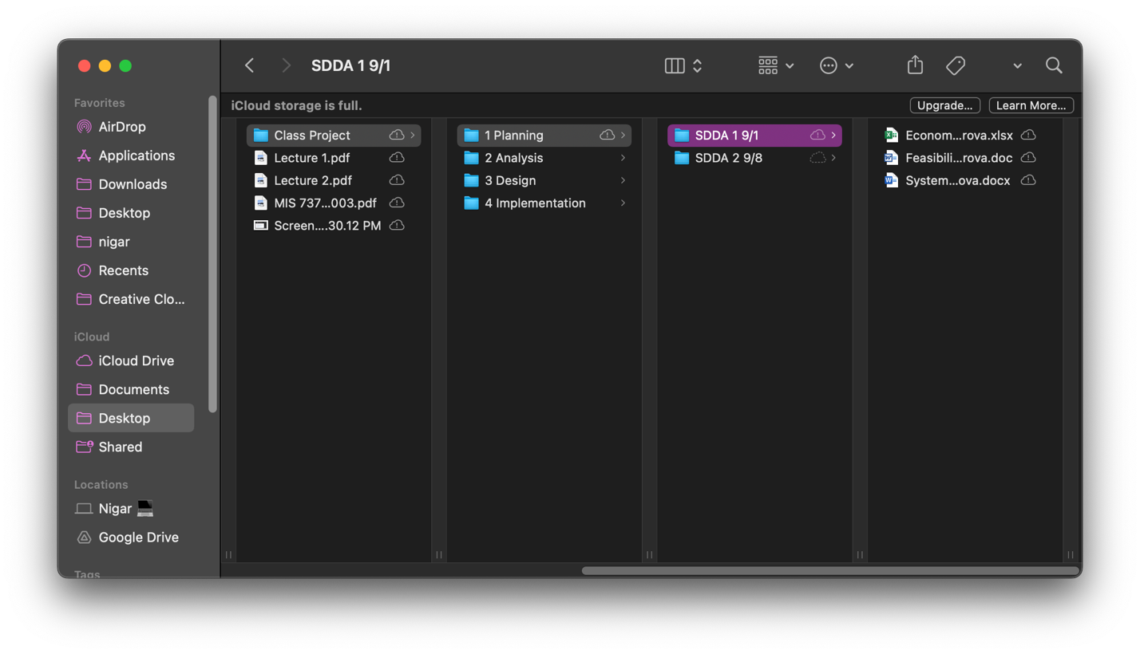

Preliminary Staffing Plan
Below is a staffing plan adjusted for a 14-week MVP. Since I am the only contributor, I will cover the core roles and timebox weekly effort to stay on schedule. A small pilot group will provide usability and acceptance feedback late in the term.
Role | Key Responsibilities | Weeks Active
Project Manager and Business Analyst | Work plan and schedule, scope and change control, risk management, requirements and acceptance criteria | 1–14
Designer | Information architecture, wireframes, basic visual style, usability checks | 4-6
Developer | Mobile app screens and logic, light backend, integrations, configuration | 6-12
QA and release | Test plan and cases, test execution, defect tracking, release packaging | 8-14
Pilot users (3-5) | Usability and acceptance feedback | 11-12

Risk Management Plan
This table is to manage risks and each row is a risk that I want to watch during the semester. The columns help me decide what to do and when to do it. The ID column lets me reference a risk in my notes. The Risk column names the problem in simple terms. L and I score likelihood and impact from 1 to 5. Exposure is the simple product of those scores which I can sort by what matters most. Prevention lists what I will do now to lower the chance or the effect. Contingency lists what I will do later if the risk happens anyway. The Owner tells me who is responsible, which is usually me. The Trigger is the signal that tells me the risk is starting to happen.
I will use this table every week and at each phase gate. I will start by checking the highest exposure items first. For example schedule slip is high, so I will protect build hours and be ready to reduce low value scope if I miss a date. I will keep the requirements baseline and a change log so scope creep stays controlled. I will test scanning early and keep manual entry as a fallback. I will track AI meal quality with a simple save rate and have curated plans ready if quality is low. I will set budget alerts for API and hosting so I can react before costs spike. I will follow App Store guidelines and test on real devices so I can pass review. I will minimize data and use clear consent text to reduce privacy and security risk. I will watch activation and weekly use so I can improve onboarding or extend the trial if adoption is soft.
This way the table becomes my weekly checklist to keep scope, time, and quality under control for the MVP.
Note: Likelihood and impact use 1 to 5. Exposure bands are low 1 to 8, medium 9 to 15, high 16 to 25.
ID | Risk | L | I | Exp | Prevention | Contingency | Owner | Trigger
R1 | Schedule slip | 4 | 4 | 16 | Time box phases and protect weekly build hours | De scope lowest value items to meet the gate | PM | Missed interim date
R2 | Scope creep | 4 | 3 | 12 | Requirements baseline and change log with a post MVP list | Move new asks to next release and communicate trade offs | BA | New must have appears
R3 | Weak OCR or scan accuracy | 3 | 4 | 12 | Early test, manual entry fallback, confidence thresholds | Remove scanning from MVP if unusable | Dev | High correction rate
R4 | AI meal relevance is low | 3 | 4 | 12 | Prompt library and editable plans with seeded examples | Ship curated starter plans and collect feedback | AI | Low plans save rate
R5 | API or hosting cost spike | 2 | 4 | 8 | Budget alerts, rate limits, cache results | Throttle noncritical calls and switch to lighter models | Dev | Budget alert
R6 | App Store rejection | 2 | 4 | 8 | Follow guidelines and test on real devices | Fix items and resubmit | PM | Rejection notice
R7 | Privacy and security issue | 2 | 5 | 10 | Data minimization, consent text, secure rules | Patch quickly and notify pilot users if needed | Sec | Report or test finding
R8 | Low adoption or retention | 3 | 4 | 12 | Five-minute onboarding and clear value messaging | Extend trial and simplify core flow | PM | Drop in activation or weekly use

